Article

Commercial vaccines do not confer protection against two genetic strains of *Piscirickettsia salmonis*, LF-89-like and EM‑90‑like, in Atlantic salmon

Carolina Figueroa 1†, Débora Torrealba 1†, Byron Morales-Lange 2, Luis Mercado 2, Brian Dixon 3, Pablo Conejeros 4, Gabriela Silva 5, Carlos Soto 5, José A. Gallardo 1,*

|  |
| --- |
| **Citation:** Figueroa, C.; Torrealba, D.; Morales-Lange, B. Title. *Biology* **2022**, *11*, x. https://doi.org/10.3390/xxxxx  Academic Editor: Firstname Lastname  Received: date  Accepted: date  Published: date  **Publisher’s Note:** MDPI stays neutral with regard to jurisdictional claims in published maps and institutional affiliations.    **Copyright:** © 2022 by the authors. Submitted for possible open access publication under the terms and conditions of the Creative Commons Attribution (CC BY) license (https://creativecommons.org/licenses/by/4.0/). |

1 Laboratorio de Genética y Genómica Aplicada, Escuela de Ciencias del Mar, Pontificia Universidad Católica de Valparaíso, Valparaíso, Chile; [cfigueroa.tm@gmail.com](mailto:cfigueroa.tm@gmail.com), [debora.torrealba@pucv.cl](mailto:debora.torrealba@pucv.cl)

2 Grupo de Marcadores Inmunológicos en Organismos Acuáticos, Instituto de Biología, Pontificia Universidad Católica de Valparaíso, Valparaíso, Chile; [byron.maximiliano.morales.lange@nmbu.no](mailto:byron.maximiliano.morales.lange@nmbu.no), [luis.mercado@pucv.cl](mailto:luis.mercado@pucv.cl)

3 Department of Biology, Faculty of Science, University of Waterloo, Waterloo, Ontario, Canada, [bdixon@uwaterloo.ca](mailto:bdixon@uwaterloo.ca)

4 Centro de Investigación y Gestión de Recursos Naturales (CIGREN), Instituto de Biología, Facultad de Ciencias, Universidad de Valparaíso, Valparaíso, Chile, [pablo.conejeros@uv.cl](mailto:pablo.conejeros@uv.cl)

5  Salmones Camanchaca, Diego Portales 2000, Puerto Montt, Chile, gabriela.silva@bmkgenetics.com, [csotomayor@salmones-dechile.cl](mailto:csotomayor@salmones-dechile.cl)

†These authors have contributed equally to this work and share first authorship

**\*** Correspondence: jose.gallardo@pucv.cl.

**Simple Summary:** Vaccination is one of the most relevant strategies to prevent and control diseases in aquaculture. However, vaccines have failed to control and prevent *Piscirickettsia salmonis*, a bacteria that produce relevant economic losses to the industry. In this work, we evaluated the performance of two commercial vaccines in Atlantic salmon through cohabitation challenge of the two most prevalent and ubiquitous isolates of *Piscirickettsia* in Chile. This study found no evidence that vaccines confer protection against LF-89-like or EM-90-like in Atlantic salmon.

**Abstract:** In Atlantic salmon, vaccines have failed to control and prevent *Piscirickettsiosis*, for reasons that remain elusive. In this study, we report the efficacy of two commercial vaccines developed with the *Piscirickettsia salmonis* isolates AL100005 and AL 20542 against other two isolates which are considered highly and ubiquitously prevalent in Chile: LF-89-like and EM-90-like. Two cohabitation trials were performed to mimic real-life conditions and vaccine performance: 1) post-smolt fish were challenged with a single infection of LF-89-like, 2) adults were coinfected with EM-90-like and a low coinfection of sea lice. In the first trial, the vaccine delayed smolt mortalities by two days; however, unvaccinated and vaccinated fish did not show significant differences in survival (unvaccinated: 60.3%, vaccinated: 56.7%; p = 0.28). In the second trial, mortality started three days later for vaccinated fish than unvaccinated fish. However, unvaccinated and vaccinated fish did not show significant differences in survival (unvaccinated: 64.6%, vaccinated: 60.2%, p= 0.58). Thus, we found no evidence that the evaluated vaccines confer effective protection against of LF-89-like or EM-90-like with estimated relative survival proportions (RPSs) of -9% and -12%, respectively. More studies are necessary to evaluate whether pathogen heterogeneity is a key determinant of the vaccine efficacy against *P. salmonis*.

**Keywords:** pentavalent vaccine; bacterin vaccine; live attenuated vaccine; monovalent vaccine; *Piscirickettsiosis*; *Salmo salar*; cohabitation; sea lice, vaccine efficacy.

1. Introduction

*Piscirickettsia salmonis* is a major concern for the Chilean salmon industry, causing economic losses of USD 700 million per year [1, 2]. *Piscirickettsiosis* is an exceptionally contagious disease, with a high prevalence in clustered regions in Chile, causing mortalities of over 50% of production [3, 4]. While Chile, the second-largest global producer of salmon, is by far the most affected country by this disease, it also affects the other main salmon producing countries, namely Norway, Canada, and Scotland [5-8].

Vaccination has been widely used as a control strategy to prevent *Piscirickettsiosis* [9], but unfortunately, all vaccines developed in the last 20 years have failed to protect Atlantic salmon against *P. salmonis* [1]. Some intrinsic and extrinsic factors that may explain why commercial vaccines present reduced protection against *P. salmonis* are: 1) coinfection with sea lice, which were able to override the protective effects of vaccines [10, 11]; 2) host genetic variation, partially protecting some hosts while leaving others unprotected [10, 11]; and 3) ineffectiveness in stimulating cellular immunity, which is a key element to protecting against *P. salmonis* because this bacteria can survive inside the host cells. Likewise, other underlying causes may lead to low vaccine efficacy, such as the pathogen’s genetic variation or poor match with circulating strain.

Since *Piscirickettsia* outbreaks in Chile are caused by a minimum of two different genetic strains, it has been suggested that this heterogeneity should be considered in vaccine development [12, 13]. The reported efficacy of a commercial vaccine would not hold in the field when testing against bacterial strains with low virulence and/or a reduced prevalence in the field. In Chile, two strains—called LF-89-like and EM-90-like—are considered highly and ubiquitously prevalent [14]. These strains show distinct laboratory growth conditions [14] and major differences in virulence-associated secretion systems and transcriptional units [15], resulting in different infective levels [16]. For example, it has been shown that EM-90-like isolates are more aggressive than the LF-89-like isolates, inducing higher cumulative mortalities (EM-90 = 95%; LF89 = 82%) and a shorter time to death (EM-90 = 42 days; LF89 = 46 days) in non-vaccinated post-smolt when evaluated by a cohabitation challenge [17, 18]. Contrary to the hypothesis of heterogeneity, an experimental vaccine developed with an isolate of EM-90 failed to protect against the same isolate [19, 20].

In this study, we tested the efficacy of two commercial vaccines against the two most prevalent Chilean strains of *Piscirickettsia*, LF-89-like, and EM-90-like. The first vaccine was a pentavalent bacterin injectable vaccine (AL100005 isolate), and the second was a combination of the pentavalent bacterin vaccine with a live attenuated injectable vaccine (AL 20542 isolate). The challenges were carried out with Atlantic salmon (*Salmo salar*) and by cohabitation with fish that successfully adapted to saline conditions in order to best imitate the natural conditions of bacterial infection. In the first trial, LF-89-like was evaluated with post-smolt fish with a single infection of *P. salmonis*, while in the second trial, EM-90-like was evaluated with adult fish in a challenge that included a very low coinfection with the sea louse *C. rogercresseyi*, again to emulate field conditions better.

2. Materials and Methods

*2.1. Ethics Statement*

This work was carried out under the guidance of the care and use of experimental animals of the Canadian Council on Animal Care. The protocol was approved by the Bioethics Committee of the Pontificia Universidad Católica de Valparaíso and the Comisión Nacional de Investigación Científica y Tecnológica de Chile (FONDECYT N° 1140772). Animals were fed daily *ad libitum* with a commercial diet. To reduce stress during handling, vaccination was performed on fish sedated with AQUI-S (50% Isoeugenol, 17 mL/100 L water). Euthanasia was performed using an overdose of anesthesia.

**Table 1.** Number and proportion of Atlantic salmon used per group and treatment for the first and second trials. In the first trial, post-smolt fish were challenged with the LF-89-like isolate of *P. salmonis*, while in the second trial, adult fish were challenged with the EM-90-like isolate of *P. salmonis* and with the sea lice *C. rogercresseyi*.

|  |  |  |  |
| --- | --- | --- | --- |
| **Group** | **Treatments** | **First trial** | **Second trial** |
| Cohabitant | Vaccinated (HV) | 496 | 83 |
|  | Unvaccinated (HUV) | 355 | 96 |
|  | Total cohabitant (H) | 851 | 179 |
|  | **HU / H** | **42%** | **53%** |
| Trojan | Total Trojans (T) | 2903 | 126 |
|  | **T / (H + T)** | **77%** | **41%** |
| Control | Vaccinated (CV) | 727 | 74 |
|  | Unvaccinated (CUV) | 506 | 63 |
|  | Total control (C) | 1233 | 137 |
|  | **Total fish (H + T + C)** | **4987** | **442** |

*2.2. Commercial vaccines*

The commercial vaccines, hereafter “the vaccine”, used in this study were a pentavalent bacterin vaccine with antigens against *P. salmonis*, *Vibrio ordalii*, *Aeromonas salmonicida*, IPNV (Infectious Pancreatic Necrosis Virus) and ISAV (Infectious Salmon Anemia Virus) and a monovalent live attenuated vaccine against *P. salmonis*. This pentavalent vaccine was the most used by Chilean farmers with 43% (3821 vaccination events over 8884 events in the freshwater phase of production), while the live vaccine reaches position number five with 6.8 % (608/8884) [9]. The active principle of the vaccine to prevent *Piscirickettsiosis* is *P. salmonis* AL 10005 strain (Pentavalent) and *P. salmonis* AL 20542 (Live). The pentavalent vaccine was used in trial 1, and both vaccines (Pentavalent and Live) were given simultaneously in trial 2 as was recommended by the manufacturer. No fish was challenged without first completing the development period of protection indicated by the manufacturer.

*2.3. Challenge with LF-89-like (Trial 1)*

A total of 4983 individually pit-tagged smolt fish were provided in 2017 by the Salmones Camanchaca Company. Fish were transferred to the experimental station of the Neosalmon Company for the evaluation of the vaccine efficacy using a cohabitation challenge (Table 1). In total, 1223 of the fish had been previously immunized with the vaccine using the normal production schedule and were used as vaccinated fish (342 ± 55 g), 861 had been previously injected with Phosphate-Buffered Saline (PBS) and were used as unvaccinated fish (314 ± 61 g), while the remaining fish were used as Trojan shedders (152 ± 38 g).

Vaccinated and unvaccinated fish were distributed in four tanks: two tanks of 15 m3 for the cohabitation challenges and two tanks of 5 m3 for the control without infection. All fish were acclimatized to the experimental conditions (salinity of 32% and a temperature of 15 ± 1 °C) and tanks for at least 15 days prior to the challenge. Further, a health check by RT-PCR was performed to verify that the fish were free of viral (ISAV and IPNV) and bacterial pathogens (*Vibrio* sp., *Flavobacterium* sp., *P. salmonis*, and *Renibacterium salmoninarum*). The cohabitation tanks were challenged by adding Trojan shedders (Table 1) which had been previously anesthetized with AQUI-S and injected with a median lethal dose (LD50) of 1×10-2 TCID/ml (TCID: median tissue culture infective dose) of LF-89-like isolate provided by ADL Diagnostics Company. The experiment was conducted 43 days after the *P. salmonis* injection of Trojans.

The LD50 used in Trojans was previously determined on 800 immunized fish with the vaccine, which were equally distributed in four treatments and two tanks of 1000 L per treatment. Treatment 1 involved injection with 1 × 10-2 TCID/ml, treatment 2 involved injection with 1 × 10-3 TCID/ml, treatment 3 involved injection with 1 × 10-4 TCID/ml, and treatment 4 involved injection with PBS. Fish were monitored daily for 30 days, and mortalities were recorded.

*2.4. Challenge with EM-90-like and coinfection with sea lice (Trial 2)*

A total of 442 individually pit-tagged adult fish were provided in 2019 by the company Salmones Camanchaca and transferred to the experimental station of the Aquadvice company for the evaluation of the efficacy vaccine using a cohabitation challenge (Table 1). In total, 157 of the fish had been previously immunized with the vaccine using the normal production schedule and were used as vaccinated fish (1,274 ± 318 g), 159 had been previously injected with PBS and were used as unvaccinated fish (1,260 ± 345 g), while the remaining fish were used as Trojan shedders (1,311 ± 346 g).

Vaccinated and unvaccinated fish were distributed in three tanks of 11 m3: two tanks for the cohabitation challenges and one tank for the control without infection. All fish were acclimatized to the experimental conditions (salinity of 32% and a temperature of 15 ± 1 °C) and tanks for at least 15 days prior to the challenge. Further, a health check by RT-PCR was performed to verify that the fish were free of viral (ISAV and IPNV) and bacterial pathogens (*Vibrio* sp., *Flavobacterium* sp., *P. salmonis*, and *Renibacterium salmoninarum*). The cohabitation tanks were challenged by adding Trojan shedders (Table 1) which had been previously anesthetized with AQUI-S and injected with a median lethal dose (LD50) of 1 × 10-3.5 TCID/ml of EM-90-like isolate provided by Fraunhofer, Chile. After seven days of the Trojan fish being challenged with *P. salmonis*, all fish (cohabitant, Trojan and control) were infested with copepodids of *C. rogercresseyi*. The coinfection procedure was established based on our previous studies [21, 22], but now a very low infection rate was applied to mimic the natural infection rates normally seen in field conditions [23]. Infections with sea lice were performed by adding 20 copepodites per fish to each control and coinfection tank. Copepodites were collected from egg-bearing females reared in the laboratory and confirmed as pathogen-free (*P. salmonis*, *R. salmoninarum*, *IPNV*, and *ISAV*) by RT-PCR diagnosis. After the addition of parasites, water flow was stopped for a period of 8 h, and tanks were covered to decrease light intensity, which favors the successful settlement of sea lice on fish [21]. Parasite counting was performed a week after the infestation in a sample of nine fish per tank. The challenge lasted 60 days after the Trojans’ infection with *P. salmonis*.

The LD50 used in Trojans was previously determined on 330 immunized fish with the vaccine, which were equally distributed in five treatments and two tanks of 720 L per treatment. Treatment 1 involved injection with 1 × 10-1.5 TCID/ml, treatment 2 involved injection with 1 × 10-2.5 TCID/ml, treatment 3 involved injection with 1×10-3.5 TCID/ml, treatment 4 involved injection with 1 × 10-4.5 TCID/ml, and treatment 5 involved injection with PBS. Fish were monitored daily for 30 days, and mortalities were recorded.

*2.5. Necropsy analysis*

Macroscopic lesions from 10 controls and cohabitant fish in each trial were analyzed. Two different veterinarians who were blinded to the treatments studied fresh samples from trials 1 or 2. In the challenge with LF-89-like, macroscopic lesions were evaluated at 21 days post-infection in the liver, where vacuolar degeneration, hepatitis, and hepatocyte atrophy were described according to their presence or absence. Further, 47 vaccinated and unvaccinated fish from cohabitation and control tanks were analyzed by immunohistochemistry to detect the presence or absence of *P. salmonis* in the liver at 21 days after challenges and at the end of the experiment. In the challenge with EM-90-like, clinical signs were evaluated at the end of the challenges; the analysis included the presence or absence of nodules in the liver, congestive liver, and hepatomegaly.

*2.6. ELISA*

An indirect Enzyme-Linked Immunosorbent Assay (ELISA) was performed in serum samples only from the first trial—the fish challenged with LF-89-like isolate. Secretion levels of total immunoglobulin (Igs), antigen-specific immunoglubulins against *P. salmonis* (spIgs), tumor necrosis factor-alpha (TNFα) and interferon-gamma (IFNγ) were measured following the protocol of Morales-Lange *et al.* [24]. Briefly, the total protein concentration of each sample was first determined by the BCA (Bicinchoninic acid) method (Pierce, Thermo Fisher, Waltham, USA) according to the supplier's instructions. Then, each sample was diluted in carbonate buffer (60 mM NaHCO3, pH 9.6), seeded in duplicate at 50 ng µL-1 (100 µL) in a Maxisorp plate (Nunc, Thermo Fisher Scientific, Waltham, USA) and incubated overnight at 4 ºC. After that, the plates were blocked with 200 µL per well of 1% Bovine Serum Albumin (BSA) for 2 h at 37 ºC, and later the primary antibodies (Table S1 and Figure S1) were incubated for 90 min at 37 ºC. Next, a secondary antibody—HRP (Thermo Fisher)—was incubated for 60 min at 37 ºC in a 1:7000 dilution. Finally, 100 µL per well of chromagen substrate 3,30,5,50-tetrame thylbenzidine (TMB) single solution (Invitrogen, California, USA) was added and incubated for 30 min at room temperature. The reaction was stopped with 50 µL of 1 N sulfuric acid and read at 450 nm on a VERSAmax microplate reader (Molecular Device, California, USA). For the detection of spIg, 50 ng µL-1 of total protein extract from *P. salmonis* [25] were seeded per well in a Maxisorp plate (diluted in 100 µL of carbonate buffer) and incubated overnight at 4 ºC. After blocking with 1% BSA (200 µL per well), each fish serum sample was incubated in duplicate at a total Igs concentration of 50 ng µL-1 for 90 min at 37 ºC. After that, the ELISA protocol described above was followed.

*2.7. Statistical analysis*

The mortality was registered in all individuals, and data were represented using Kaplan–Meier survival curves [26]. The protection elicited by vaccines was determined by comparing the survival percentage of vaccinated and unvaccinated groups using a Log-rank test. Further, the Relative Proportion Survival (RPS) was calculated as

RPS (%) = (1 – A/B) * 100

where A and B are the mortalities at the end of challenges in vaccinated and unvaccinated fish, respectively.

Additionally, differences in the clinical signs of *P. salmonis* infection between different treatments were analyzed using a non-parametric Chi-square test. Finally, significant differences in ELISA tests were compared using the Student’s two-tailed t-test, p < 0.05. All statistical analyses were performed using R Core Team (RStudio, Vienna, Austria). Graphs were designed with GraphPad Prism 8.0 software (GraphPad Software, CA, USA).

**3. Results**

* 1. *Vaccine efficacy against LF-89-like isolate*

As we expected, the cohabitation challenge with the LF-89-like isolate of *P. salmonis* resulted in high mortality in the cohabiting fish and no mortality in the non-infected control fish. However, we found no evidence that the pentavalent vaccine generated an effective protection against *P. salmonis* LF-89 strain. The vaccine delayed mortalities by two days (HUV: 34 dpi and HV: 36 dpi), but unvaccinated fish and those vaccinated showed similar survival during and at the end of the challenges (HV: 56.7% and HUV: 60.3%, Figure 1A). Therefore, the survival test did not reveal significant differences between vaccinated and unvaccinated treatments (p = 0.28).

Dead fish and large numbers of vaccinated and unvaccinated live fish at the end of the challenge showed multiple hemorrhagic ulcers on the skin typical of a severe *P.*

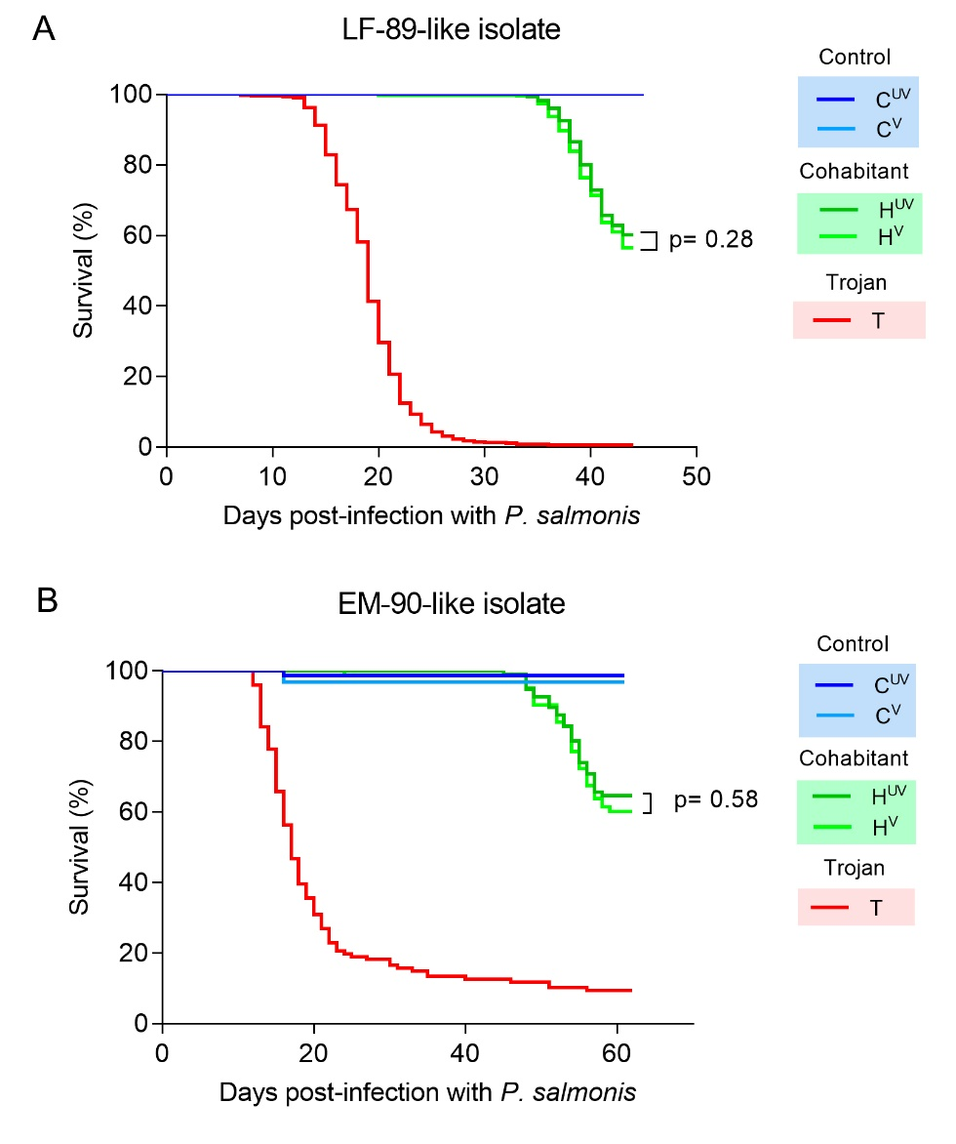

Figure 1. Survival curves: (A) Single infection of Atlantic salmon post-smolt with the *P. salmonis* LF‑89-like strain. (B) Coinfection of Atlantic salmon adults with the *P. salmonis* EM-90-like strain and the sea louse *C. rogercresseyi*. Fish from the first trial were immunized with Pentavalent injectable vaccine, and fish from the second trial with Pentavalent injectable plus monovalent live injectable. Abbreviations: CUV: control unvaccinated; CV: control vaccinated; HUV: cohabitant unvaccinated; HV: cohabitant vaccinated; T: trojan.

*salmonis* infection. Infection with *P. salmonis* was also evident in both vaccinated and unvaccinated fish in the liver at the end of the challenge but not at 21 days after infection (Figure 2). On the other hand, vaccination increased the presence of hepatocyte atrophy in comparison with unvaccinated fish in the control treatment at 21 days post-infection

(Table 2). A similar trend was observed in the cohabitant fish, but without significant differences (Table 2). Once the challenge is over, the health status of fish was evaluated against most common salmon diseases, revealing the appearance of secondary infections of *Piscine orthoreovirus* (Figure S3) and *Tenacibaculum dicentrarchi* in some fish.

The ELISA results in serum samples of *S. salar* showed a significant increase of total Igs at 21 days post-infection (Figure 3A) in the control group of vaccinated fish (CV). However, at the same sampling time, cohabiting fish (unvaccinated and vaccinated) showed a decrease in total Igs levels. This trend was reversed at 41 dpi, since both groups (HUV and HV) significantly increased their levels of total Igs. On the other hand, regarding specific

**Figure 2.** Presence of LF-89-like isolate of *P. salmonis* (black arrows) in liver samples of Atlantic salmon. *Piscirickettsiosis* was detected in 11 out of 47 fish analyzed by immunohistochemistry — magnification 63X.

immunoglobulins against *P. salmonis* (Figure 3B), an increase was detected in CV before the challenge with *P. salmonis*. Nevertheless, after 41 days post-infection, HV group showed less availability of spIgs against *P. salmonis* than the other groups. Finally, the evaluation of TNFα and IFNγ secretion did not show significant changes between treatments (Figure 3C-D).

* 1. *Vaccine efficacy against EM-90-like isolate with low sea lice coinfection*

In the second trial, adult fish were coinfected with sea lice to mimic natural conditions in the field. Seven days after sea lice infestation, the prevalence of sea lice was 100% in treatment and control tanks, with no significant differences in the abundance of the parasites between tanks (Tank 1 = 10.4 ± 4.0; Tank 2 = 11.7 ± 3.0; Control tank = 9.7 ± 6.6). In cohabitant fish with low-level sea lice infection, the vaccine (Pentavalent injectable + monovalent live injectable) was not able to protect Atlantic salmon against the EM-90-like strain (HV: 60.2% and HUV: 64.6%; Figure 1B; p = 0.58). However, a small effect of delayed

**Table 2.** Clinical signs in Atlantic salmon challenged with the LF-89-like isolate of *P. salmonis* at day 21 post-infection in cohabitant and control groups. Differences between vaccinated and unvaccinated fish were evaluated with a Chi-squared statistical test. Abbreviations: UV: unvaccinated fish and V: vaccinated fish.

|  |  |  |  |  |  |  |  |  |
| --- | --- | --- | --- | --- | --- | --- | --- | --- |
| **Group** | **Clinical signs** | **Presence of clinical signs** | **Treatment** | | **Proportion** | | **Chi-square test** | |
| **UV** | **V** | **UV** | **V** | *X2* | ***p-value*** |
| Cohabitant | Vacuolar | No | 2 | 4 | 0.2 | 0.4 | 0.24 | 0.63 |
| degeneration | Yes | 8 | 6 | 0.8 | 0.6 |  |  |
|  | Total | 10 | 10 |  |  |  |  |
|  | Hepatitis | No | 9 | 9 | 0.9 | 0.9 | 0 | 1 |
|  | Yes | 1 | 1 | 0.1 | 0.1 |  |  |
|  |  | Total | 10 | 10 |  |  |  |  |
|  | Hepatocyte | No | 8 | 4 | 0.8 | 0.4 | 1.88 | 0.17 |
|  | atrophy | Yes | 2 | 6 | 0.2 | 0.6 |  |  |
|  |  | Total | 10 | 10 |  |  |  |  |
| Control | Vacuolar | No | 1 | 3 | 0.1 | 0.3 | 0.31 | 0.58 |
| degeneration | Yes | 9 | 7 | 0.9 | 0.7 |  |  |
|  | Total | 10 | 10 |  |  |  |  |
|  | Hepatitis | No | 8 | 7 | 0.8 | 0.7 | 0 | 1 |
|  | Yes | 2 | 3 | 0.2 | 0.3 |  |  |
|  |  | Total | 10 | 10 |  |  |  |  |
|  | Hepatocyte | No | 10 | 5 | 1 | 0.5 | 4.27 | <0.05* |
|  | atrophy | Yes | 0 | 5 | 0 | 0.5 |  |  |
|  |  | Total | 10 | 10 |  |  |  |  |

mortalities was observed; for example, steady mortality started three days later for vaccinated fish compared with unvaccinated fish (HV: 48 dpi and HUV: 45 dpi). The control tank infected only with sea lice presented very low mortalities, with one fish dead of the unvaccinated fish (CUV) and two dead of the vaccinated fish (CV).

Vaccinated and unvaccinated dead fish showed hemorrhagic ulcers on the skin typical of a severe *P. salmonis* infection. Further, when we compared cohabitant and control fish at the end of the challenges, infection with *P. salmonis* was evident in the cohabitant fish in terms of the three evaluated clinical signs: nodules in liver, congestive liver, and hepatomegaly (Table 3). However, we did not find differences between vaccinated and unvaccinated fish in cohabitant fish (Table 3). For instance, in the cohabitant treatment, nine unvaccinated fish presented a congestive liver, compared to 10 vaccinated fish with that condition. Similar patterns were found for nodules in the liver and hepatomegaly.

4. Discussion

Vaccination is one of the most relevant strategies to prevent and control diseases in aquaculture [27]. However, vaccines have failed to control and prevent *Piscirickettsiosis*, for reasons that remain elusive [1, 28-30]. This manuscript evaluated whether the heterogeneity of *P. salmonis* could explain the low vaccine efficacy of a commercial vaccine whose active principle is a bacterin developed using the *P. salmonis* AL 10005 and a live attenuated vaccine developed with AL 20542 strains. To do that, we evaluated the vaccine efficacy using the two most prevalent and ubiquitous isolates of *P. salmonis* in Chile. Challenges were designed to mimic the natural condition of infection; thus, LF-89-like was evaluated with post-smolt fish in a single infection of *P. salmonis*, and EM-90-like was evaluated with adult fish in a challenge that included a very low coinfection pressure with the sea louse *C. rogercresseyi*. Thus, in this study, we found no evidence that vaccines developed with the *P. salmonis* AL 10005 or AL 20542 strains confer protection against LF-89-like or EM-90-like in Atlantic salmon.

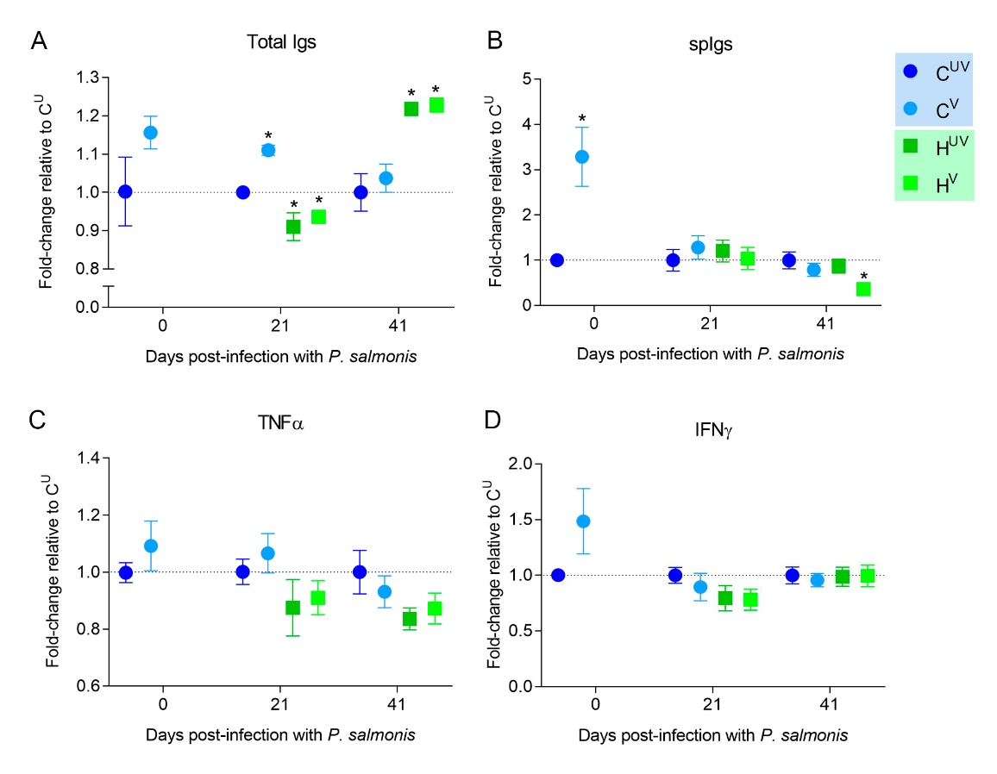**Figure 3.** Measurement of protein levels by ELISA:Secretion of total Igs (**A**), antigen specific Igs (**B**), tumor necrosis factor alpha (TNFα) (**C**), and interferon gamma (IFNγ) (**D**) in serum samples from Atlantic salmon measured by ELISA after a challenge with *P. salmonis* in the first trial (single infection of the LF-89-like isolate). Fish immunized with Pentavalent injectable vaccine. Data represent the mean ± SEM (n = 10). Significant differences compared to CUV by Student t-test two-tailed (p<0.05). Abbreviations: CUV: control unvaccinated; CV: control vaccinated; HUV: cohabitant unvaccinated; HV: cohabitant vaccinated.

The absent or low level of protection provided by vaccines against *Piscirickettsia* could be related to the selection of an incorrect model for the evaluation of protection in vaccination trials, which may lead to the overestimation of the real protective value of

vaccines in the field. For example, the route of infection has been proposed as a relevant factor for defining the performance of a vaccine. Here, we selected a cohabitation model of challenges, because cohabitation challenges best mimic the natural infection route [31]. On the other hand, several studies evaluating vaccine efficacy against *P. salmonis* have been performed by intraperitoneal injection [32-35]. Intraperitoneal injection is preferred because it is a synchronized and effective infection route that shortens the time to produce disease symptoms, decreasing the cost of trials [19, 20]. Vaccine protection efficacy has been found to be affected by the route of infection for furunculosis [36] but not for *Piscirickettsiosis* in Atlantic salmon [20].

On the other hand, coinfection with other pathogens such as sea lice is usually not considered in the evaluation of *P. salmonis* vaccine efficacy in laboratory-controlled conditions. We consider that this overestimates the true ability of vaccines to control *Piscirickettsiosis* for three reasons: first, sea lice are highly prevalent in the ocean; second, the long culture times in the sea ensure that fish will be infected not once only but several times by this pathogen; third, it has been shown that sea lice can override the protective effects of vaccination [10]. We observed no clinical signs associated with *P. salmonis* in the control tank, and mortality was significantly lower in the control tanks (less than 2–%; 3 of 137 fish) than in the cohabitating plus coinfection treatment (36–40%). Because we did not

Table 3. Clinical signs in Atlantic salmon challenged with the EM-90-like isolate of *P. salmonis* and infestation with *C. rogercresseyi* at day 47–51 post-infection in cohabitant and control groups. Differences between vaccinated and unvaccinated fish were evaluated with a Chi-squared statistical test. Abbreviations: UV: unvaccinated fish and V: vaccinated fish.

|  |  |  |  |  |  |  |  |  |
| --- | --- | --- | --- | --- | --- | --- | --- | --- |
| **Group** | **Clinical signs** | **Presence of clinical signs** | **Treatment** | | **Proportion** | | **Chi-square test** | |
| **UV** | **V** | **UV** | **V** | *X2* | ***p-value*** |
| Cohabitant | Nodules in | No | 0 | 0 | 0 | 0 | 0 | 1 |
| liver | Yes | 10 | 10 | 1 | 1 |  |  |
|  | Total | 10 | 10 |  |  |  |  |
|  | Congestive | No | 1 | 0 | 0.1 | 0 | 0.02 | 0.96 |
| liver | Yes | 9 | 10 | 0.9 | 1 |  |  |
|  |  | Total | 10 | 10 |  |  |  |  |
|  | Hepatomegaly | No | 0 | 0 | 0 | 0 | 0 | 1 |
|  |  | Yes | 10 | 10 | 1 | 1 |  |  |
|  |  | Total | 10 | 10 |  |  |  |  |
| Control | Nodules in | No | 10 | 10 | 1 | 1 | 0 | 1 |
| liver | Yes | 0 | 0 | 0 | 0 |  |  |
|  | Total | 10 | 10 |  |  |  |  |
|  | Congestive | No | 10 | 9 | 1 | 0.9 | 0 | 1 |
| liver | Yes | 0 | 1 | 0 | 0.1 |  |  |
|  |  | Total | 10 | 10 |  |  |  |  |
|  | Hepatomegaly | No | 10 | 9 | 1 | 0.9 | 0 | 1 |
|  |  | Yes | 0 | 1 | 0 | 0.1 |  |  |
|  |  | Total | 10 | 10 |  |  |  |  |

observe differences in mortality or clinical signs between vaccinated and unvaccinated adult fish in the cohabitating treatment, we predict that the evaluated vaccine will not protect fish in the field.

The immune mechanisms involved in vaccine protection against *P. salmonis* are poorly understood. In this research, the vaccine was able to induce an increase of spIgs in vaccinated fish. However, this occurred before the challenge with *P. salmonis*. After the challenge, cohabiting fish showed only increases in total Igs (41 dpi) and even a decrease of spIgs against *P. salmonis* to 41 dpi, perhaps due to B cell depletion. Apparently, the vaccine is not able to activate components of acquired immunity such as specific antibodies or cytokines associated with TH1 profiles (TNFα and IFNγ) once fish face *P. salmonis* infection, perhaps because *P. salmonis* is an intracellular pathogen. This suggests that the vaccine could act as an immunostimulant for the adaptive response at early time points, but not as a vaccine that induces future specific secondary responses. It has already been reported that vaccines may induce weaker or shorter-lived immunity in fish, mainly due to the low immunogenicity of the antigens used or because they cannot modulate the antigen presentation processes effectively during the different stages of immunity [37]. Therefore, the protective mechanism that *Piscirickettsia* vaccines might have in the field [9] needs to be clarified.

In Chile, the Agricultural and Livestock Service of Chile (SAG) authorized *P. salmonis* vaccines that meet a minimum protection of ≥70% RPS to be marketed. However, there is little evidence of their effectiveness under field conditions [9]. In this study, the minimum protection of RPS ≥70% was not reproduced either against *P. salmonis* LF-89 strain or in the EM-90 strain. Unfortunately, neither the pharmaceutical companies nor the SAG (Agricultural and Livestock Service) publicly release the efficacy studies that authorize the marketing of vaccines in Chile. This prevented us from comparing our results with the studies carried out by pharmaceutical companies. Vaccine efficacy studies must be public and must consider both the genetic heterogeneity of the host and the pathogen’s heterogeneity. In fact, we do not know if the most vulnerable groups of populations have been included when the efficacy of the *Piscirickettsiosis* vaccine was evaluated by the SAG as recommended by the World Organization for Animal Health (OIE) or if pathogen heterogeneity was considered.

**Supplementary Materials:** The following supporting information can be downloaded at: www.mdpi.com/xxx/s1, Table S1: Primary polyclonal antibodies used in ELISA analysis; Figure S1: Validation of antibodies against total serum immunoglobulins (Igs) of *Salmo salar*: (**a**) Indirect ELISA calibration curve between total serum Igs concentration of *S. salar* (ng µL-1) and optical density at 450 nm; (**b**) Western blot. Antibodies were produced in mice using total serum Igs from Atlantic salmon as antigen. The antigen was obtained by the caprylic acid technique for immunoglobulin purification (Fishman and Berg, 2018. DOI: 10.1101 / pdb.prot099127); Figure S2. Presence of Piscine orthoreovirus (black arrows) in heart samples of Atlantic salmon from the first trial at day 41 post infection with LF-89-like isolate of *P. salmonis*. The virus was detected in 7 out of 17 fish analyzed by immunohistochemistry—magnification 63X.

**Author Contributions:** J.A.G., C.S., C.F., G.S. conceived and designed the study with the help of PC and B.D. C.F., G.S., C.S., and J.A.G. performed the experiments. C.F. and D.T. performed the data analysis. B.M. and L.M performed the analysis of the Immunological data. D.T. and J.A.G. wrote the paper with the help of all authors.

**Funding:** This research study was funded by CONICYT-Chile through the project FONDECYT N°1140772 awarded to J.A.G and P.C. Furthermore, J.A.G was supported by the Cooperative Research Program Fellowships of OECD - PCI 2015-CONICYT. C.F. was supported by PUCV and CONICYT-Chile through a Postdoctoral fellowship (Proyecto VRIEA-PUCV Postdoctorado and FONDECYT N°3170744). D.T. was supported by CONICYT-Chile through a Postdoctoral fellowship (Becas-Chile N° 74170029). B.M-L was supported by the Postdoctoral program from the National Research and Development Agency of Chile (ANID-Chile 74200139).

**Institutional Review Board Statement:** The animal study protocol was approved by the Bioethics Committee of the Pontificia Universidad Católica de Valparaíso and the Comisión Nacional de Investigación Científica y Tecnológica de Chile (FONDEC-YT N° 1140772).

**Data Availability Statement:** In this section, please provide details regarding where data supporting reported results can be found, including links to publicly archived datasets analyzed or generated during the study. Please refer to suggested Data Availability Statements in section “MDPI Research Data Policies” at https://www.mdpi.com/ethics. If the study did not report any data, you might add “Not applicable” here.

**Acknowledgments:** We wish to thank all of the staff from the salmon selective breeding program at Salmones Camanchaca, with special thanks to Darwin Muñoz, Sonia Velazquez and Sergio Navarro for their professional support and collaboration in the experimental work. We would like to thank Salmones Camanchaca for providing fish, materials and logistics to perform this study. We would like to thank the staff of Neosalmon and Aquadvise for their valuable contribution to the development of experiments.

**Conflicts of Interest:** We declare that J.A.G., L.M., and P.C. provided genetic and immunological services to different salmon companies in Chile during the execution of this experiment. G.S and C.S. were employed in Salmones Camanchaca during the execution of this research. C.F., D.T., B.M-L, and B.D. declare no competing financial interest.

References

1. Maisey, K., R. Montero, and M. Christodoulides, *Vaccines for piscirickettsiosis (salmonid rickettsial septicaemia, SRS): the Chile perspective.* Expert Rev Vaccines, 2017. **16**(3): p. 215-228.

2. Rozas, M. and R. Enriquez, *Piscirickettsiosis and Piscirickettsia salmonis in fish: a review.* J Fish Dis, 2014. **37**(3): p. 163-88.

3. Jakob, E., et al., *Epidemiology of Piscirickettsiosis on selected Atlantic salmon (Salmo salar) and rainbow trout (Oncorhynchus mykiss) salt water aquaculture farms in Chile.* Aquaculture, 2014. **433**: p. 288-294.

4. Leal, J. and D. Woywood, *Piscirickettsiosis en Chile: Avances y perspectivas para su control.* Salmonciencia, 2007. **2**: p. 34-42.

5. Brocklebank, J., et al., *Rickettsial septicemia in farmed Atlantic and chinook salmon in British Columbia: Clinical presentation and experimental transmission.* Can Vet J, 1993. **34**: p. 745 - 748.

6. Grant, A.N., et al., *Rickettsia‐like organism in farmed salmon. .* Veterinary Record, 1996. **138**(17).

7. Olsen, A.J., et al., *Piscirickettsia salmonis infection in Atlantic salmon Salmo salar in Norway-epidemiological, pathological and microbiological findings.* 1997. **31**: p. 35-48.

8. SERNAPESCA, *Informe Sanitario de Salmonicultura en Centros Marinos 2016. Valparaíso: Servicio Nacional de Pesca y Acuicultura.* 2017.

9. Happold, J., et al., *Effectiveness of vaccination for the control of salmonid rickettsial septicaemia in commercial salmon and trout farms in Chile.* Aquaculture, 2020. **520**: p. 734968.

10. Figueroa, C., et al., *Coinfection takes its toll: Sea lice override the protective effects of vaccination against a bacterial pathogen in Atlantic salmon.* Sci Rep, 2017. **7**(1): p. 17817.

11. Figueroa, C., et al., *Host genetic variation explains reduced protection of commercial vaccines against Piscirickettsia salmonis in Atlantic salmon.* Sci Rep, 2020. **10**(1): p. 18252.

12. Nourdin-Galindo, G., et al., *Comparative Pan-Genome Analysis of Piscirickettsia salmonis Reveals Genomic Divergences within Genogroups.* Front Cell Infect Microbiol, 2017. **7**: p. 459.

13. Otterlei, A., et al., *Phenotypic and genetic characterization of Piscirickettsia salmonis from Chilean and Canadian salmonids.* BMC Vet Res, 2016. **12**: p. 55.

14. Saavedra, J., et al., *Prevalence, geographic distribution and phenotypic differences of Piscirickettsia salmonis EM-90-like isolates.* J Fish Dis, 2017. **40**(8): p. 1055-1063.

15. Millar, A., et al., *Draft genomes and reference transcriptomes extend the coding potential of the fish pathogen Piscirickettsia salmonis.* Electronic Journal of Biotechnology, 2018. **33**: p. 36-38.

16. Bohle, H., et al., *Comparative Genome Analysis of Two Isolates of the Fish Pathogen Piscirickettsia salmonis from Different Hosts Reveals Major Differences in Virulence-Associated Secretion Systems.* GenomeA, 2014. **2**(6).

17. Rozas-Serri, M., et al., *Comparative pathogenesis of piscirickettsiosis in Atlantic salmon (Salmo salar L.) post-smolt experimentally challenged with LF-89-like and EM-90-like Piscirickettsia salmonis isolates.* J Fish Dis, 2017. **40**(10): p. 1451-1472.

18. Rozas-Serri, M., et al., *Comparison of gene expression in post-smolt Atlantic salmon challenged by LF-89-like and EM-90-like Piscirickettsia salmonis isolates reveals differences in the immune response associated with pathogenicity.* J Fish Dis, 2018. **41**(3): p. 539-552.

19. Cardella, M.A. and M.E. Eimers, *Safety and Potency Testing of Federally Licensed Fish Bacterins.* Journal of Aquatic Animal Health, 1990. **2**(1): p. 49-55.

20. Meza, K., et al., *Comparative evaluation of experimental challenge by intraperitoneal injection and cohabitation of Atlantic salmon (Salmo salar L) after vaccination against Piscirickettsia salmonis (EM90-like).* J Fish Dis, 2019. **42**(12): p. 1713-1730.

21. Araya, A., et al., *Experimental challenges of Atlantic salmon Salmo salar with incremental levels of copepodids of sea louse Caligus rogercresseyi: effects on infestation and early development.* Aquaculture Research, 2012. **43**(12): p. 1904-1908.

22. Lhorente, J.P., et al., *Disease resistance in Atlantic salmon (Salmo salar): coinfection of the intracellular bacterial pathogen Piscirickettsia salmonis and the sea louse Caligus rogercresseyi.* PLoS One, 2014. **9**(4): p. e95397.

23. Bravo, S., et al., *Effectiveness of hydrogen peroxide in the control of Caligus rogercresseyi in Chile and implications for sea louse management.* Aquaculture, 2010. **303**(1-4): p. 22-27.

24. Morales-Lange, B., et al., *Detection of peroxiredoxin-like protein in Antarctic sea urchin (Sterechinus neumayeri) under heat stress and induced with pathogen-associated molecular pattern from Vibrio anguillarum.* Polar Biology, 2018. **41**(10): p. 2065-2073.

25. Carril, G., F. Gómez, and S. Marshall, *Expression of flagellin and key regulatory flagellar genes in the non-motile bacterium Piscirickettsia salmonis.* Dis Aquat Org. , 2017. **123**: p. 29-43.

26. Kaplan, E.L. and P. Meier, *Nonparametric Estimation from Incomplete Observations.* Journal of the American Statistical Association, 1958. **53**(282): p. 457-481.

27. Assefa, A. and F. Abunna, *Maintenance of Fish Health in Aquaculture: Review of Epidemiological Approaches for Prevention and Control of Infectious Disease of Fish.* Vet Med Int, 2018. **2018**: p. 5432497.

28. Adams, A., *Progress, challenges and opportunities in fish vaccine development.* Fish Shellfish Immunol, 2019. **90**: p. 210-214.

29. Alvarez, C.A., et al., *Piscirickettsia salmonis Imbalances the Innate Immune Response to Succeed in a Productive Infection in a Salmonid Cell Line Model.* PLoS One, 2016. **11**(10): p. e0163943.

30. Cabello, F.C. and H.P. Godfrey, *Salmon aquaculture, Piscirickettsia salmonis virulence, and One Health: Dealing with harmful synergies between heavy antimicrobial use and piscine and human health.* Aquaculture, 2019. **507**: p. 451-456.

31. Nordmo, R., *Strengths and weaknesses of different challenge methods.* Developments in Biological Standardization, 1997. **90**: p. 303-309.

32. Kuzyk, M., et al., *An efficacious recombinant subunit vaccine against the salmonid rickettsial pathogen Piscirickettsia salmonis.* Vaccine, 2001. **19**: p. 2337-2344.

33. Salonius, K., et al., *Use of Arthrobacter davidanieli as a live vaccine against Renibacterium salmoninarum and Piscireckettsia salmonis in salmonis.* Progress in Fish Vaccinology, 2005. **121**: p. 189-197.

34. Tobar, J.A., et al., *Oral vaccination of Atlantic salmon (Salmo salar) against salmonid rickettsial septicaemia.* Vaccine, 2011. **29**(12): p. 2336-40.

35. Wilhelm, V., et al., *A vaccine against the salmonid pathogen Piscirickettsia salmonis based on recombinant proteins.* Vaccine, 2006. **24**(23): p. 5083-91.

36. Midtlyng, P., *Critical assessment of regulatory standards and tests for fi sh vaccines*, in *Progress in fi sh vaccinology*, M. PJ, Editor. 2005: Developments of Biologicals

37. Rozas-Serri, M., A. Pena, and L. Maldonado, *Gene expression associated with immune response in Atlantic salmon head-kidney vaccinated with inactivated whole-cell bacterin of Piscirickettsia salmonis and pathogenic isolates.* Fish Shellfish Immunol, 2019. **93**: p. 789-795.